Name:Hamza Irshad

Section: D

Sap: 70070357

Course: DB

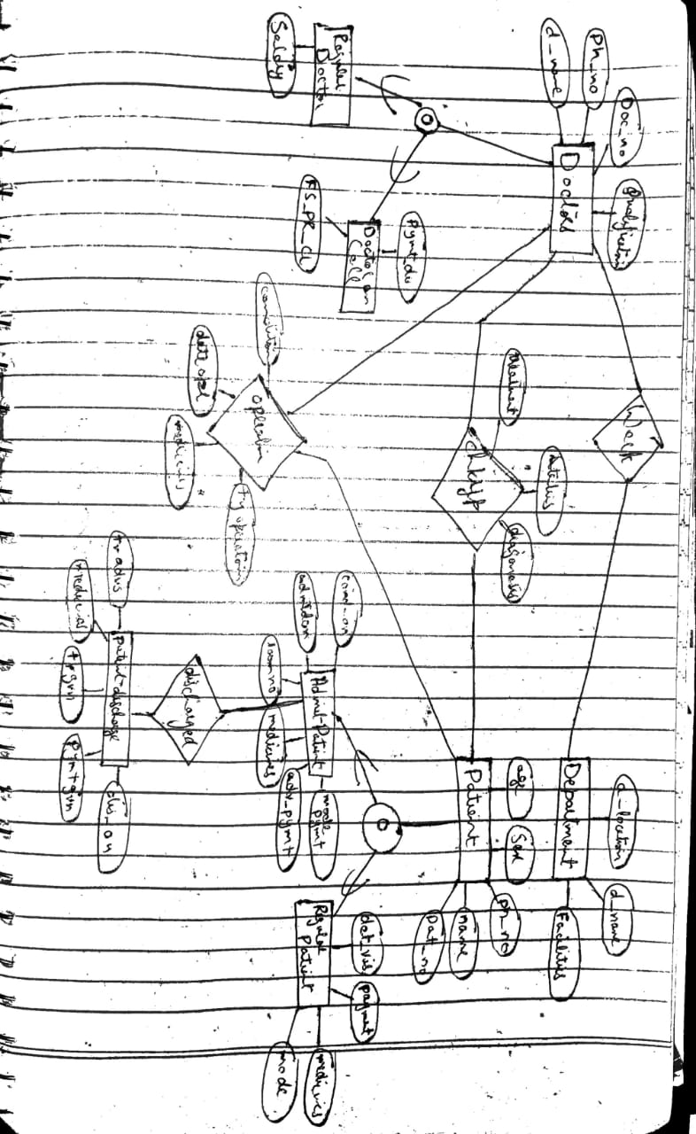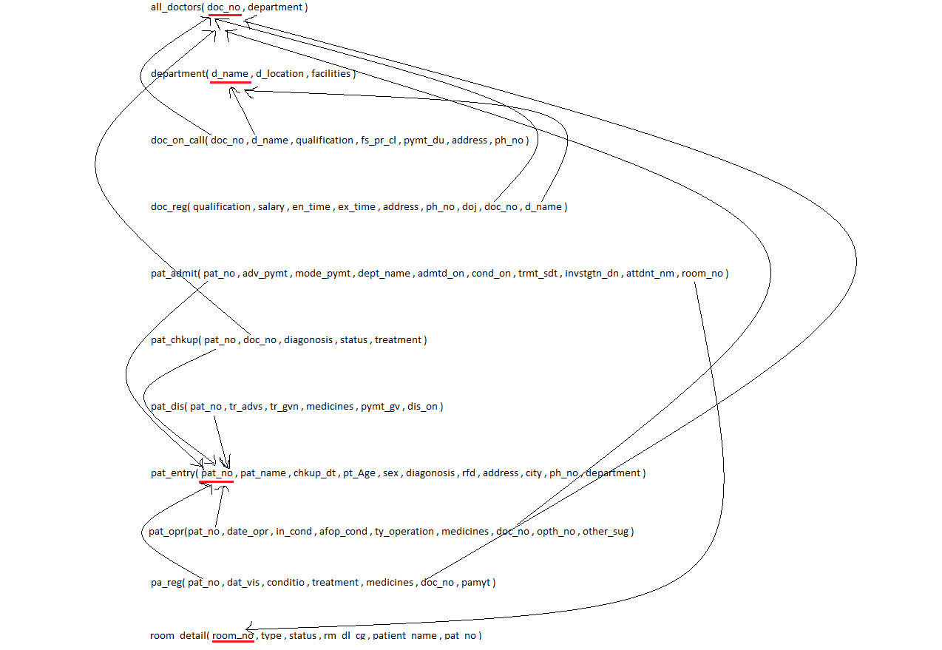

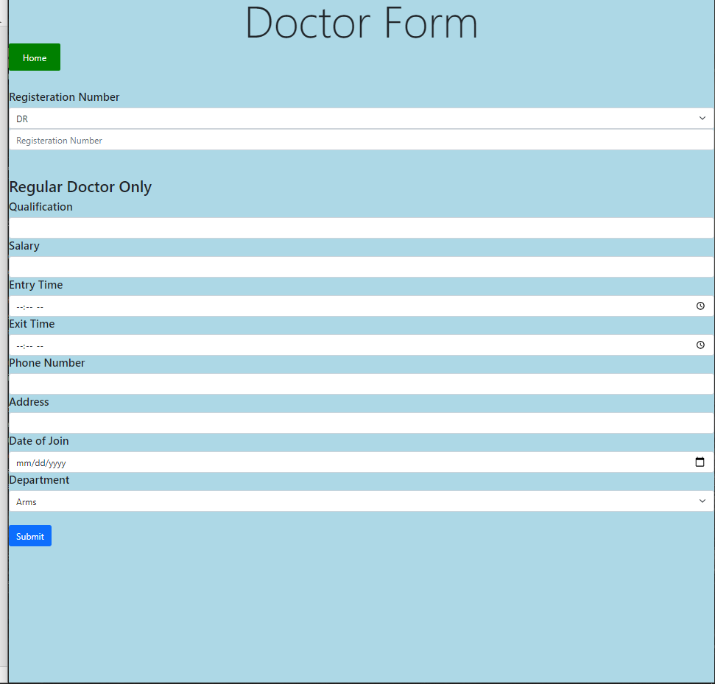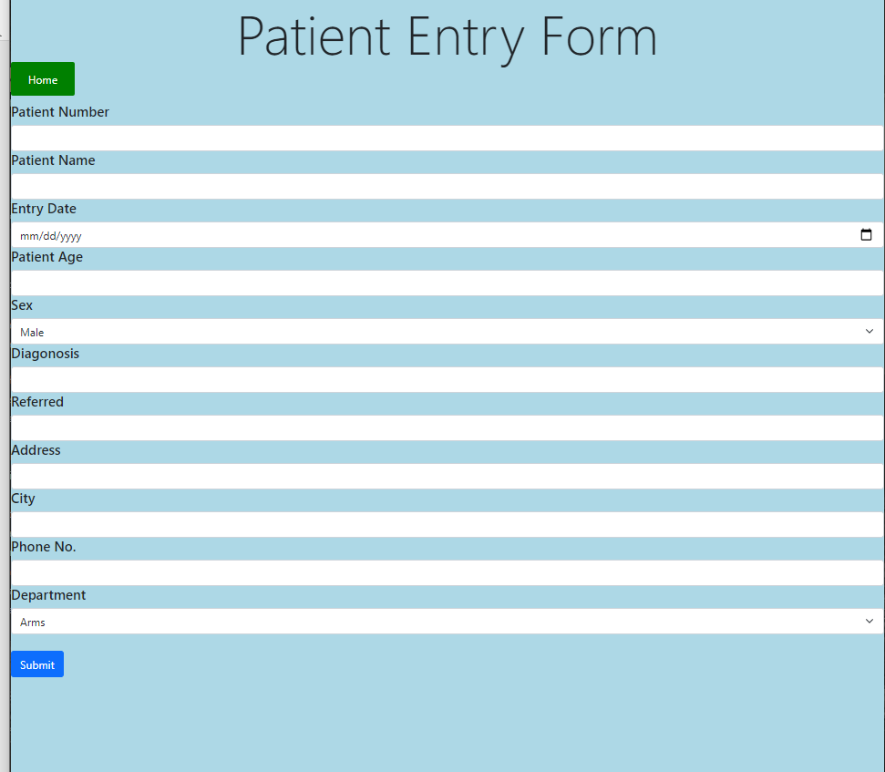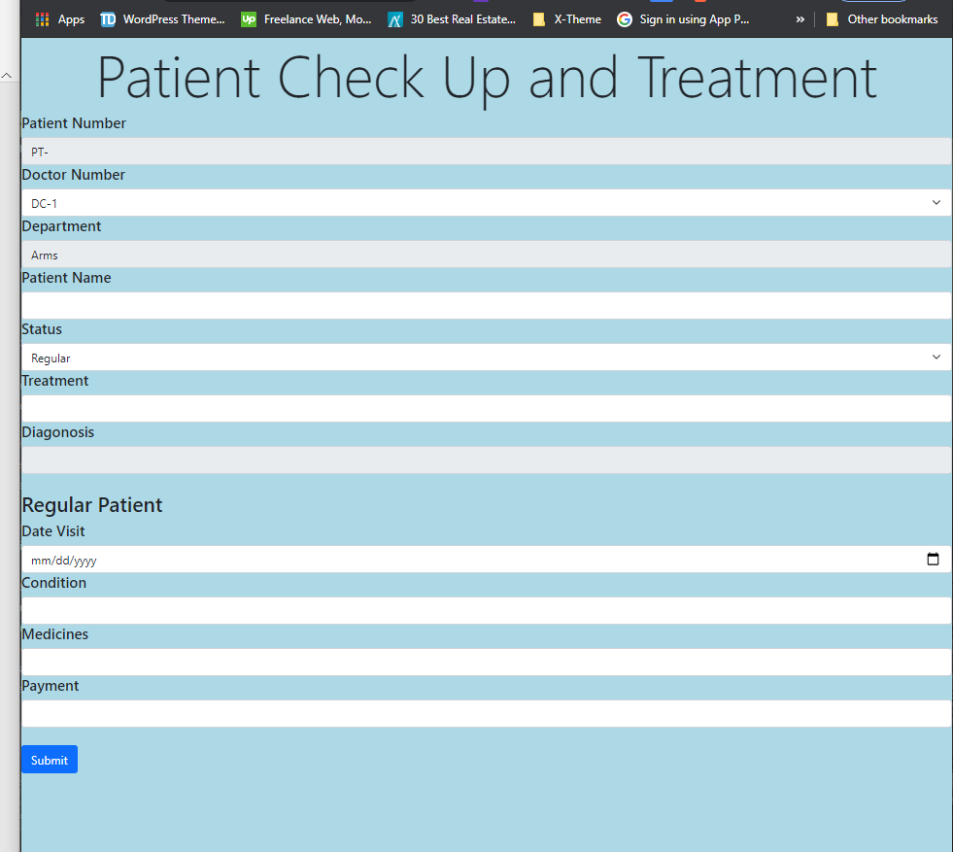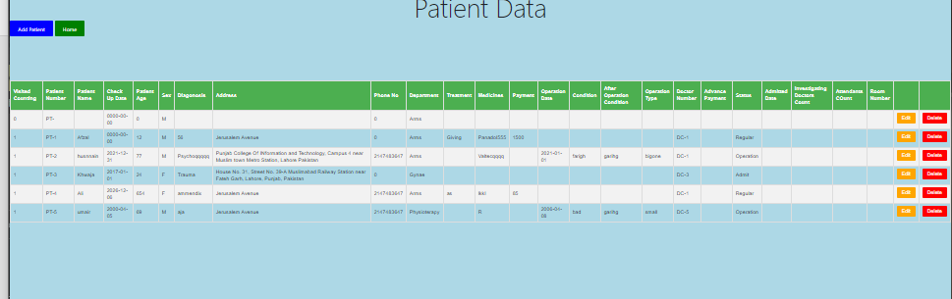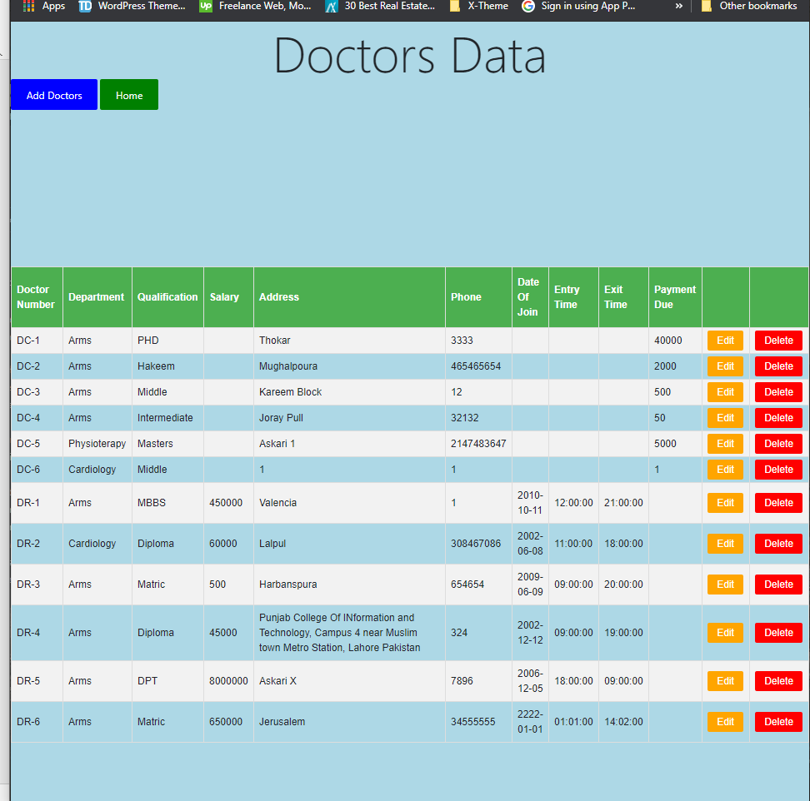

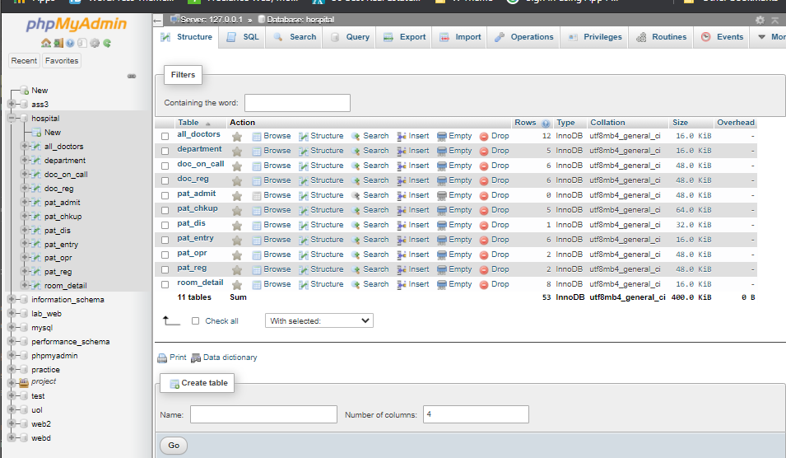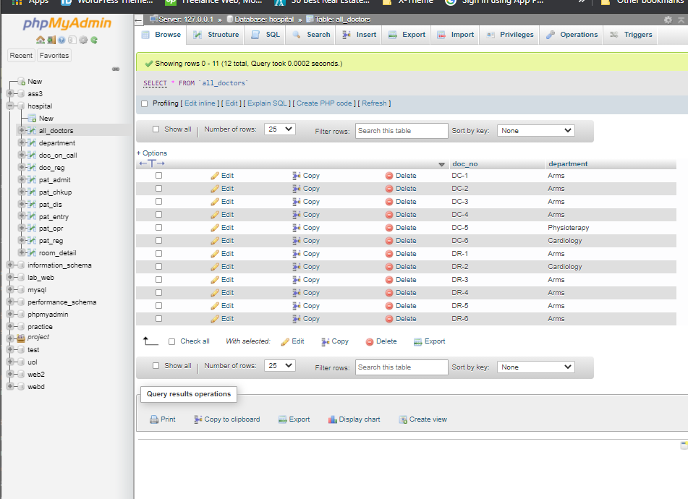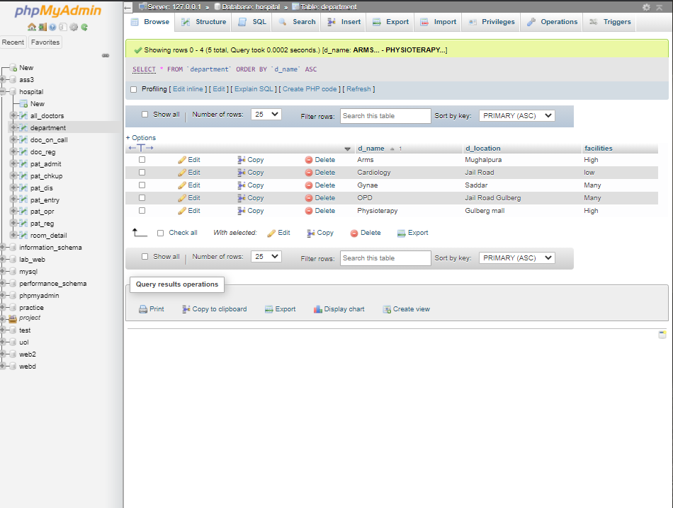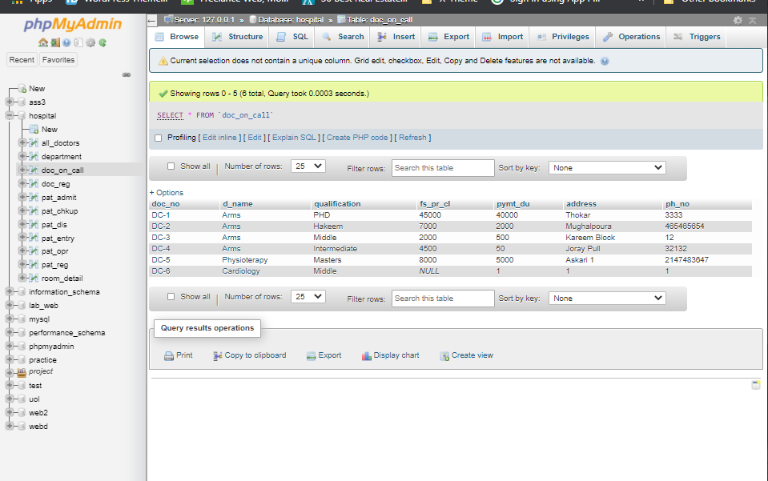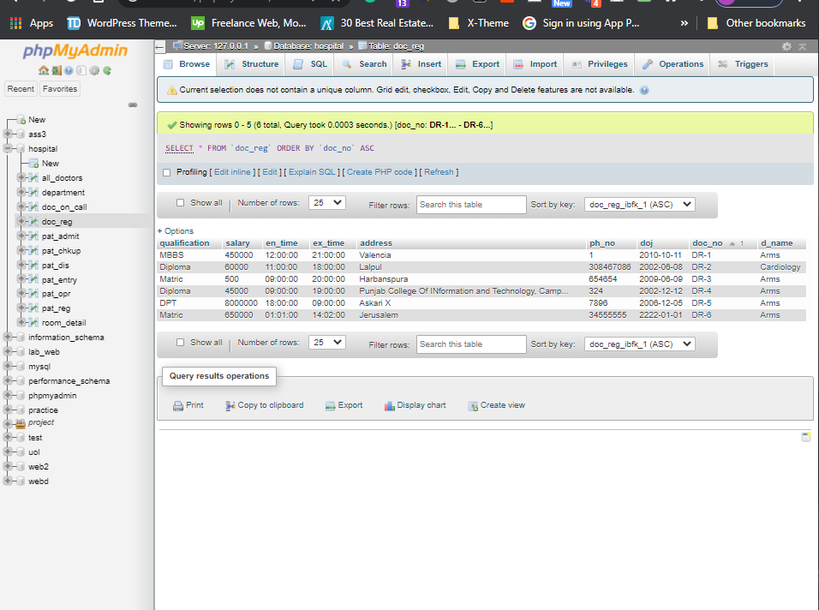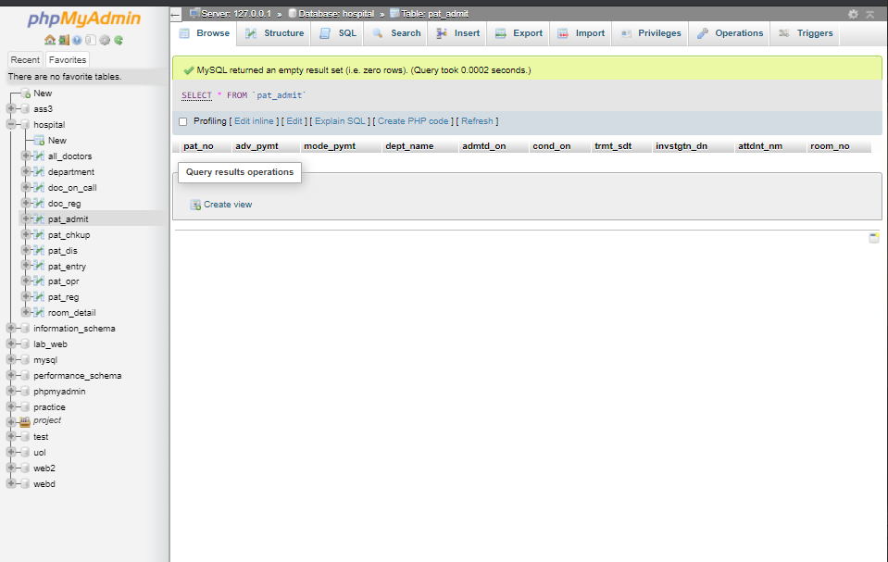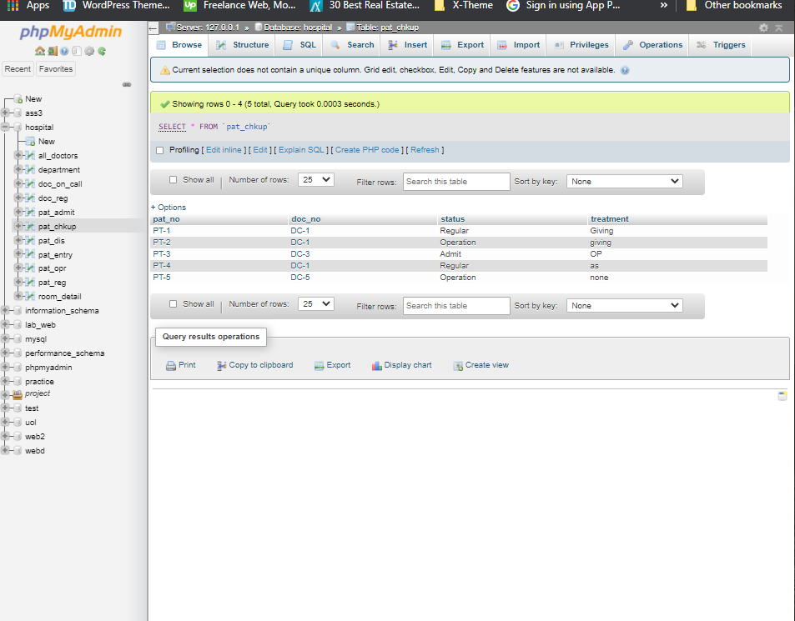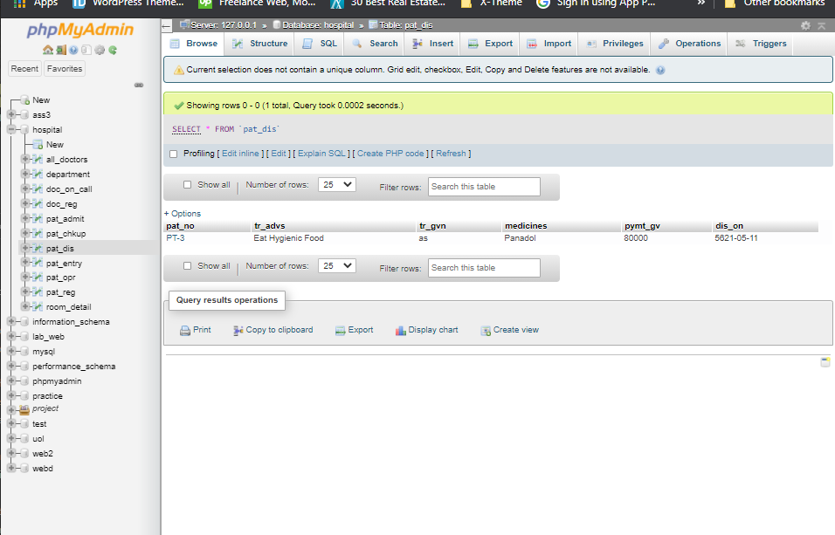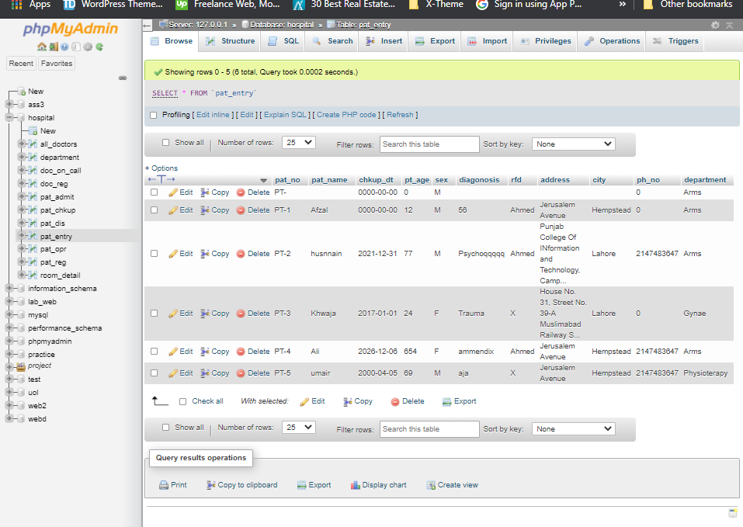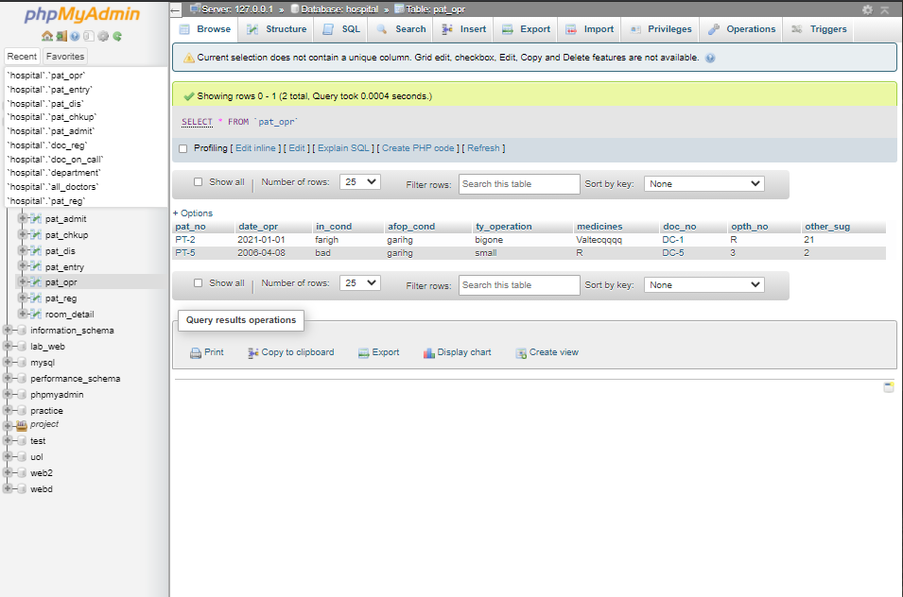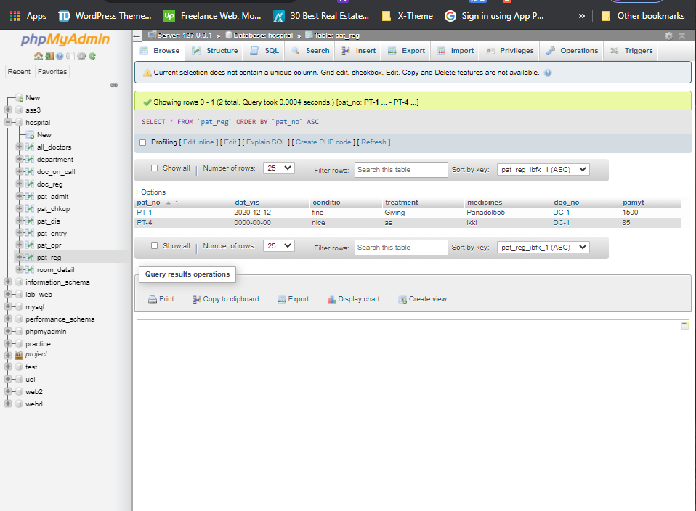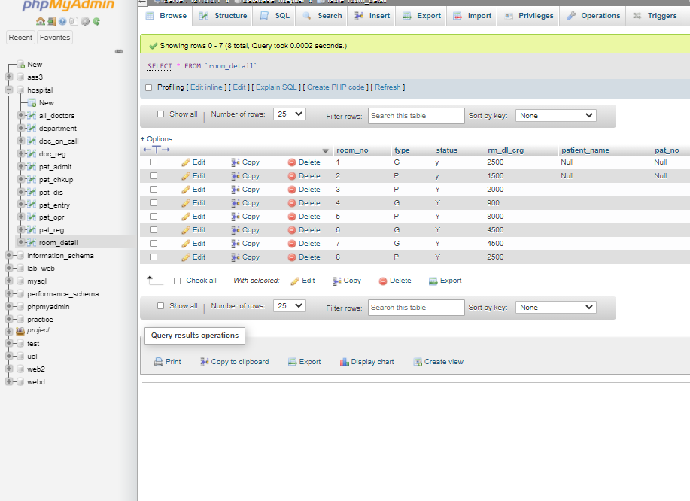

Doctorform.php(alldoctors,doc_on_call,doc_reg,doc_opr):-

<!DOCTYPE html>

<html>

<head>

<link href="https://cdn.jsdelivr.net/npm/bootstrap@5.0.1/dist/css/bootstrap.min.css" rel="stylesheet" integrity="sha384-+0n0xVW2eSR5OomGNYDnhzAbDsOXxcvSN1TPprVMTNDbiYZCxYbOOl7+AMvyTG2x" crossorigin="anonymous">

<style type="text/css">

.add{

background-color: blue;

color: white;

text-decoration: none;

text-align: center;

padding: 14px 25px;

border-radius: 3px;

}

.add:hover{

color: white;

background-color: red;

}

</style>

<script src="https://code.jquery.com/jquery-1.12.4.js"></script>

<script src="https://code.jquery.com/ui/1.12.1/jquery-ui.js"></script>

<script>

function displayDivDemo(id, elementValue) {

document.getElementById(id).style.display = elementValue.value == 'DR' ? 'block' : document.getElementById('call').style.display = 'block';

document.getElementById(id).style.display = 'none';

}

</script>

</head>

<body style="background-color: lightblue; ">

<?php

$con=mysqli_connect("localhost","root","");

$db=mysqli_select_db($con,"hospital");

$dept="select d_name from department";

$query_dep=mysqli_query($con,$dept);

$dep="select d_name from department";

$query_dept=mysqli_query($con,$dep);

?>

<h1 class="display-1" align="center">Doctor Form</h1>

<a href="home.php" class="add" style="background-color: green;">Home</a><br><br><br>

<form action="doctorentry.php" method="post">

<label class="h5">Registeration Number</label><br>

<select name="selector" class="form-select" onchange="displayDivDemo('reg', this)" >

<option value="DR">DR</option>

<option value="DC">DC</option></select>

<input type="text" name="doc_no" placeholder="Registeration Number" class="form-control" id="exampleFormControlInput1">

<br><br>

<div id="reg" style="display: block;">

<h3>Regular Doctor Only</h3>

<label class="h5">Qualification</label>

<input type="text" name="qualification" class="form-control" id="exampleFormControlInput1">

<label class="h5">Salary</label>

<input type="text" name="salary" class="form-control" id="exampleFormControlInput1">

<label class="h5">Entry Time</label>

<input type="time" name="en_time" class="form-control" id="exampleFormControlInput1">

<label class="h5">Exit Time</label>

<input type="time" name="ex_time" class="form-control" id="exampleFormControlInput1">

<label class="h5">Phone Number</label>

<input type="phone" name="ph_no" class="form-control" id="exampleFormControlInput1">

<label class="h5">Address</label>

<input type="text" name="address" class="form-control" id="exampleFormControlInput1">

<label class="h5">Date of Join</label>

<input type="date" name="doj" class="form-control" id="exampleFormControlInput1">

<label class="h5">Department</label>

<select name="d_name" class="form-select">

<?php

while ($res= mysqli_fetch_array($query_dep)) {

?>

<option><?php echo $res['d_name']; ?></option>

<?php } ?>

</select>

</div><br>

<div id="call" style="display: none;">

<h3>On Call Doctor Only</h3>

<label class="h5">Qualification</label>

<input type="text" name="qualificationcall" class="form-control" id="exampleFormControlInput1">

<label class="h5">Fees Per Call</label>

<input type="text" name="fs_pr_clcall" class="form-control" id="exampleFormControlInput1">

<label class="h5">Payment Due</label>

<input type="text" name="pymt_ducall" class="form-control" id="exampleFormControlInput1">

<label class="h5">Address</label>

<input type="text" name="addresscall" class="form-control" id="exampleFormControlInput1">

<label class="h5">Phone Number</label>

<input type="phone" name="ph_nocall" class="form-control" id="exampleFormControlInput1">

<label class="h5">Department</label>

<select name="d_namee" class="form-select" >

<?php

while ($re= mysqli_fetch_array($query_dept)) {

?>

<option><?php echo $re['d_name']; ?></option>

<?php } ?>

</select>

</div>

<input type="submit" name="submit" class="btn btn-primary">

</form>

</body>

</html>

Doctorentry.php:-

<?php

$con=mysqli_connect("localhost","root","");

$db=mysqli_select_db($con,"hospital");

if($_POST['submit'])

{

$check=$_POST['selector'];

if ($check === 'DR' ) {

$string="DR";

$doc_no=$string . "-" . $_POST['doc_no'];

$d_name=$_POST['d_name'];

$qualification=$_POST['qualification'];

$salary=$_POST['salary'];

$en_time=$_POST['en_time'];

$ex_time=$_POST['ex_time'];

$address=$_POST['address'];

$ph_no=$_POST['ph_no'];

$doj=$_POST['doj'];

$all="insert into all_doctors (doc_no,department) values ('$doc_no','$d_name')";

$all_query=mysqli_query($con,$all);

$query="Insert into doc_reg (qualification,salary,en_time,ex_time,address,ph_no,doj,doc_no,d_name) values('$qualification','$salary','$en_time','$ex_time','$address',$ph_no,'$doj','$doc_no','$d_name')";

$insert_doc=mysqli_query($con,$query);

}

else

{

$string="DC";

$doc_no=$string . "-" . $_POST['doc_no'];

$d_namee=$_POST['d_namee'];

$qualification=$_POST['qualificationcall'];

$address=$_POST['addresscall'];

$ph_nocl=$_POST['ph_nocall'];

$fs_pr_cl=$_POST['fs_pr_clcall'];

$pymt_du=$_POST['pymt_ducall'];

$all1="insert into all_doctors (doc_no,department) values ('$doc_no','$d_namee')";

$all_query=mysqli_query($con,$all1);

$query1="Insert into doc_on_call (doc_no,d_name,qualification,fs_pr_cl,pymt_du,address,ph_no) values ('$doc_no','$d_namee','$qualification','$fs_pr_cl','$pymt_du','$address',$ph_nocl)";

$insert_doc=mysqli_query($con,$query1);

}

header("location:showdoctors.php");

}

?>

Departmententry.php:-

<!DOCTYPE html>

<html>

<head>

<title></title>

<link href="https://cdn.jsdelivr.net/npm/bootstrap@5.0.1/dist/css/bootstrap.min.css" rel="stylesheet" integrity="sha384-+0n0xVW2eSR5OomGNYDnhzAbDsOXxcvSN1TPprVMTNDbiYZCxYbOOl7+AMvyTG2x" crossorigin="anonymous">

<style type="text/css">

.add{

background-color: blue;

color: white;

text-decoration: none;

text-align: center;

padding: 14px 25px;

border-radius: 3px;

}

.add:hover{

color: white;

background-color: red;

}

</style>

</head>

<body style="background-color: lightblue; ">

<?php

$con=mysqli_connect("localhost","root","");

$db=mysqli_select_db($con,"hospital");

if (isset($_POST['deptsubmit']))

{

$d_name=$_POST['d_name'];

$d_location=$_POST['d_location'];

$facilities=$_POST['facilities'];

$query="Insert Into department (d_name,d_location,facilities) values ('$d_name','$d_location','$facilities')";

$query_dept=mysqli_query($con,$query);

if ($query_dept) {

header("location:showdepartment.php");

# code...

}

# code...

}

?>

<h2 class="display-1" align="center">Department Entry</h2>

&nbsp&nbsp<a href="home.php" class="add" style="background-color: green;">Home</a><br><br>

<form action="" method="post">

<label class="h5"> Department name</label> <input type="text" name="d_name" class="form-control" id="exampleFormControlInput1">

<label class="h5">Department Location</label> <input type="text " name="d_location" class="form-control" id="exampleFormControlInput1">

<label class="h5">Facilities</label> <input type="text" name="facilities" class="form-control" id="exampleFormControlInput1">

<Br>

&nbsp&nbsp<input type="submit" name="deptsubmit" class="btn btn-primary">

</form>

</body>

</html>

Patiententry.php:-

<?php

$con=mysqli_connect("localhost","root","");

$db=mysqli_select_db($con,"hospital");

$dept="select d_name from department";

$query_dep=mysqli_query($con,$dept);

?>

<!DOCTYPE html>

<html>

<head>

<link href="https://cdn.jsdelivr.net/npm/bootstrap@5.0.1/dist/css/bootstrap.min.css" rel="stylesheet" integrity="sha384-+0n0xVW2eSR5OomGNYDnhzAbDsOXxcvSN1TPprVMTNDbiYZCxYbOOl7+AMvyTG2x" crossorigin="anonymous">

<style type="text/css">

.add{

background-color: blue;

color: white;

text-decoration: none;

text-align: center;

padding: 14px 25px;

border-radius: 3px;

}

.add:hover{

color: white;

background-color: red;

}

</style>

<title></title>

</head>

<body style="background-color: lightblue; ">

<h2 class="display-1" align="center">Patient Entry Form</h2>

<a href="home.php" class="add" style="background-color: green;">Home</a><br><br>

<form action="patiententrysubmit.php" method="post">

<label class="h5">Patient Number</label>

<input type="text" name="pat_no" class="form-control" id="exampleFormControlInput1">

<label class="h5"> Patient Name</label>

<input type="text" name="pat_name" class="form-control" id="exampleFormControlInput1">

<label class="h5">Entry Date</label>

<input type="date" name="chkkup_dt" class="form-control" id="exampleFormControlInput1">

<label class="h5">Patient Age</label>

<input type="text" name="pt_age" class="form-control" id="exampleFormControlInput1">

<label class="h5">Sex</label><br>

<SELECT name="sex" class="form-select"><option value="M" >Male</option>

<option value="F">Female</option>

</SELECT>

<label class="h5">Diagonosis</label>

<input type="text" name="diagonosis" class="form-control" id="exampleFormControlInput1">

<label class="h5">Referred </label>

<input type="text" name="rfd" class="form-control" id="exampleFormControlInput1">

<label class="h5">Address</label>

<input type="text" name="address" class="form-control" id="exampleFormControlInput1">

<label class="h5">City</label>

<input type="text" name="city" class="form-control" id="exampleFormControlInput1">

<label class="h5">Phone No.</label>

<input type="phone" name="ph_no" class="form-control" id="exampleFormControlInput1">

<label class="h5">Department</label><br>

<select name="d_name" class="form-select">

<?php

while ($res= mysqli_fetch_array($query_dep)) {

?>

<option value="<?php echo $res['d_name']; ?>"><?php echo $res['d_name']; ?></option>

<?php } ?>

</select><br>

<input type="submit" name="submit" class="btn btn-primary">

</form>

</body>

</html>

Patiententrysubmit.php:-

<?php

$con=mysqli_connect("localhost","root","");

$db=mysqli_select_db($con,"hospital");

$pat_no="PT-" . $_POST['pat_no'];

$pat_name=$_POST['pat_name'];

$chkkup_dt=$_POST['chkkup_dt'];

$pt_age=$_POST['pt_age'];

$sex=$_POST['sex'];

$diagonosis=$_POST['diagonosis'];

$rfd=$_POST['rfd'];

$address=$_POST['address'];

$city=$_POST['city'];

$ph_no=$_POST['ph_no'];

$department=$_POST['d_name'];

if (isset($_POST['submit'])) {

$query="Insert into pat_entry (pat_no,pat_name,chkup_dt,pt_age,sex,diagonosis,rfd,address,city,ph_no,department) values ('$pat_no','$pat_name','$chkkup_dt','$pt_age','$sex','$diagonosis','$rfd','$address','$city','$ph_no','$department')";

$queryrun=mysqli_query($con,$query);

}

$dept="select doc_no from all_doctors where department='$department'";

$query_dep=mysqli_query($con,$dept);

$dep11="select d_name from department";

$query_dep11=mysqli_query($con,$dep11);

$queryr="Select room_no,type,status from room_detail where status='Y'";

$queryro=mysqli_query($con,$queryr);

?>

<!DOCTYPE html>

<html>

<head>

<link href="https://cdn.jsdelivr.net/npm/bootstrap@5.0.1/dist/css/bootstrap.min.css" rel="stylesheet" integrity="sha384-+0n0xVW2eSR5OomGNYDnhzAbDsOXxcvSN1TPprVMTNDbiYZCxYbOOl7+AMvyTG2x" crossorigin="anonymous">

<title></title>

<script>

function displayDivDemo( elementValue) {

if (elementValue.value==='Regular') {

document.getElementById('op').style.display= 'none';

document.getElementById('adm').style.display= 'none';

document.getElementById('reg').style.display= 'block';

}

if (elementValue.value==='Operation') {

document.getElementById('reg').style.display= 'none';

document.getElementById('adm').style.display= 'none';

document.getElementById('op').style.display= 'block';

}

if (elementValue.value==='Admit') {

document.getElementById('op').style.display= 'none';

document.getElementById('reg').style.display= 'none';

document.getElementById('adm').style.display= 'block';

}

}

</script>

</head>

<body style="background-color: lightblue; ">

<h2 class="display-1" align="center">Patient Check Up and Treatment</h2>

<form action="patientchecksubmit.php" method="POST">

<label class="h5">Patient Number</label>

<input type="text" name="pat_no" value="<?php echo $pat_no ; ?> " readonly class="form-control" id="exampleFormControlInput1" >

<label class="h5">Doctor Number</label>

<select name="doc_no" class="form-select">

<?php

while ($ress= mysqli_fetch_array($query_dep)) {

?>

<option><?php echo $ress['doc_no']; ?></option>

<?php } ?>

</select>

<label class="h5">Department</label>

<input type="text" name="dept_name" value="<?php echo $department ; ?>" readonly class="form-control" id="exampleFormControlInput1">

<label class="h5">Patient Name</label>

<input type="text" name="pat_name" value="<?php echo $pat_name ; ?>" class="form-control" id="exampleFormControlInput1">

<label class="h5">Status</label>

<select name="status" onchange="displayDivDemo( this)" class="form-select">

<option value="Regular">Regular</option>

<option value="Operation">Operation</option>

<option value="Admit">Admit</option>

</select>

<label class="h5">Treatment</label>

<input type="text" name="treatment" class="form-control" id="exampleFormControlInput1">

<label class="h5">Diagonosis</label>

<input type="text" name="diagonosis" value="<?php echo $diagonosis ; ?>" readonly class="form-control" id="exampleFormControlInput1">

<br>

<div id="reg"><h3>Regular Patient</h3>

<label class="h5">Date Visit</label>

<input type="Date" name="dat_vis" class="form-control" id="exampleFormControlInput1">

<label class="h5">Condition</label>

<input type="text" name="conditio" class="form-control" id="exampleFormControlInput1">

<label class="h5">Medicines</label>

<input type="text" name="medicines" class="form-control" id="exampleFormControlInput1">

<label class="h5">Payment</label>

<input type="text" name="paymt" class="form-control" id="exampleFormControlInput1">

</div>

<div id="op" style="display: none;"><h3>Operation Patients</h3>

<label class="h5">Date Operation</label>

<input type="Date" name="date_opr" class="form-control" id="exampleFormControlInput1">

<label class="h5">In Condition Before Operation</label>

<input type="text" name="in_cond" class="form-control" id="exampleFormControlInput1">

<label class="h5">After Operation Cndition</label>

<input type="text" name="afop_cond" class="form-control" id="exampleFormControlInput1">

<label class="h5">Type Of Operation</label>

<input type="text" name="ty_operation" class="form-control" id="exampleFormControlInput1">

<label class="h5">Medicines</label>

<input type="text" name="medicinesop" class="form-control" id="exampleFormControlInput1">

<label class="h5">Operation Theatre Number</label>

<input type="text" name="opth_no" class="form-control" id="exampleFormControlInput1">

<label class="h5">Other Surgeons</label>

<input type="text" name="other_sug" class="form-control" id="exampleFormControlInput1">

</div>

<div id="adm" style="display: none;"><h3>Admit Patients</h3>

<label class="h5">Advance Payment</label>

<input type="text" name="adv_pymt" class="form-control" id="exampleFormControlInput1">

<label class="h5">Mode Of Payment</label>

<input type="text" name="mode_pymt" class="form-control" id="exampleFormControlInput1">

<label class="h5">Admitted On</label>

<input type="date" name="admtd_on" class="form-control" id="exampleFormControlInput1">

<label class="h5">Cndition</label>

<input type="text" name="cond_on" class="form-control" id="exampleFormControlInput1">

<label class="h5">Investigating Doctor Numbers</label>

<input type="text" name="invstgtn_dn" class="form-control" id="exampleFormControlInput1">

<label class="h5">Attendent Numbers</label>

<input type="text" name="attdnt_nm" class="form-control" id="exampleFormControlInput1">

<label class="h5">Room Number</label>

<select name="room_no" class="form-select" >

<?php

while ($resro= mysqli_fetch_array($queryro) ){

?>

<option value="<?php echo $resro['room_no']?>"> <?php echo $resro['room_no']?> </option>

<?php } ?>

</select>

</div><br>

<input type="submit" name="submit" class="btn btn-primary">

</form>

</body>

</html>

Pat_checksubmit.php(pat_chkup,paT_entry,pat_opr):-

<?php

$con=mysqli_connect("localhost","root","");

$db=mysqli_select_db($con,"hospital");

if (isset($_POST['submit'])) {

$status=$_POST['status'];

$pat_no=$_POST['pat_no'];

$doc_no=$_POST['doc_no'];

$dept_name=$_POST['dept_name'];

$treatment=$_POST['treatment'];

$diagonosis=$_POST['diagonosis'];

$pat_name=$_POST['pat_name'];

if ($status === 'Regular') {

$dat_vis=$_POST['dat_vis'];

$conditio=$_POST['conditio'];

$medicines=$_POST['medicines'];

$paymt=$_POST['paymt'];

$queryreg="Insert into pat_reg (pat_no,dat_vis,conditio,treatment,medicines,doc_no,pamyt) values('$pat_no','$dat_vis','$conditio','$treatment','$medicines','$doc_no','$paymt')";

$queryregrun=mysqli_query($con,$queryreg);

if ($queryregrun) {

echo "reg";

# code...

}

$querymain="insert into pat_chkup (pat_no,doc_no,status,treatment) values ('$pat_no','$doc_no','$status','$treatment')";

$querymainrun=mysqli_query($con,$querymain);

if($querymainrun)

{

echo "REG";

}

}

if ($status === 'Operation') {

$date_opr=$_POST['date_opr'];

$in_cond=$_POST['in_cond'];

$afop_cond=$_POST['afop_cond'];

$ty_operation=$_POST['ty_operation'];

$medicinesop=$_POST['medicinesop'];

$opth_no=$_POST['opth_no'];

$other_sug=$_POST['other_sug'];

$querymain1="insert into pat_chkup (pat_no,doc_no,status,treatment) values ('$pat_no','$doc_no','$status','$treatment')";

$querymainrun1=mysqli_query($con,$querymain1);

if ($querymainrun1) {

echo "op1";

# code...

}

$queryop="insert into pat_opr(pat_no,date_opr,in_cond,afop_cond,ty_operation,medicines,doc_no,opth_no,other_sug) values ('$pat_no','$date_opr','$in_cond','$afop_cond','$ty_operation','$medicinesop','$doc_no','$opth_no','$other_sug')";

$queryoprun=mysqli_query($con,$queryop);

if ($queryoprun) {

echo "op";

# code...

}

}

if ($status === 'Admit') {

$adv_pymt=$_POST['adv_pymt'];

$mode_pymt=$_POST['mode_pymt'];

$admtd_on=$_POST['admtd_on'];

$cond_on=$_POST['cond_on'];

$invstgtn_dn=$_POST['invstgtn_dn'];

$attdnt_nm=$_POST['attdnt_nm'];

$room_no=$_POST['room_no'];

echo $pat_no;

echo $adv_pymt;

echo $mode_pymt;

echo $dept_name;

echo $admtd_on;

echo $cond_on;

echo $treatment;

echo $invstgtn_dn;

echo $attdnt_nm;

echo $room_no;

$querymain2="insert into pat_chkup (pat_no,doc_no,status,treatment) values ('$pat_no','$doc_no','$status','$treatment')";

$querymainrun2=mysqli_query($con,$querymain2);

if ($querymainrun2) {

# code...

echo "adm1";

}

$queryass="Insert INTO pat_admit (pat_no,adv_pymt,mode_pymt,dept_name,admtd_on,cond_on,trmt_sdt,invstgtn_dn,attdnt_nm,room_no) values ('$pat_no','$adv_pymt','$mode_pymt','$dept_name','$admtd_on','$cond_on','$treatment','$invstgtn_dn','$attdnt_nm',$room_no)";

$queryassrun=mysqli_query($con,$queryass);

if ($queryassrun) {

echo "main runn";

# code...

}

$queryadm1="Update room_detail set status='N', patient_name='$pat_name' , pat_no='$pat_no' where room_no=$room_no";

$queryadm1run=mysqli_query($con,$queryadm1);

if ($queryadm1run) {

echo "adm3";

# code...

}

}

}

?>

Patientdischarge.php:-

<?php

$con=mysqli_connect("localhost","root","");

$db=mysqli_select_db($con,"hospital");

$query="Select pat_no from pat_admit" ;

$query1=mysqli_query($con,$query) ;

?>

<!DOCTYPE html>

<html>

<head>

<link href="https://cdn.jsdelivr.net/npm/bootstrap@5.0.1/dist/css/bootstrap.min.css" rel="stylesheet" integrity="sha384-+0n0xVW2eSR5OomGNYDnhzAbDsOXxcvSN1TPprVMTNDbiYZCxYbOOl7+AMvyTG2x" crossorigin="anonymous">

<style type="text/css">.add{

background-color: blue;

color: white;

text-decoration: none;

text-align: center;

padding: 14px 25px;

border-radius: 3px;

}</style>

<title></title>

</head>

<body style="background-color: lightblue; ">

<h3 class="display-1" align="center">Patient Discharge Data</h3>

<a href="home.php" class="add" style="background-color: green;">Home</a><br><br>

<form action="dischargesubmit.php" method="post">

<label class="h5">Patient Number</label>

<select name="pat_no" class="form-select">

<?php

while ($res= mysqli_fetch_array($query1)) {

?>

<option><?php echo $res['pat_no'] ;?></option>

<?php } ?>

</select>

<label class="h5"> Treatment Advise</label>

<input type="text" name="tr_advs" class="form-control" id="exampleFormControlInput1">

<label class="h5">Treatment Given</label>

<input type="text" name="tr_gvn" class="form-control" id="exampleFormControlInput1">

<label class="h5">Medicines</label>

<input type="text" name="medicines" class="form-control" id="exampleFormControlInput1">

<label class="h5">Payment Given</label>

<input type="text" name="pymt_gv" class="form-control" id="exampleFormControlInput1">

<label class="h5">Discharge On </label>

<input type="Date" name="dis_on" class="form-control" id="exampleFormControlInput1"><br>

<input type="submit" name="submit" class="btn btn-primary">

</form>

</body>

</html>

Dischargesubmit.php:-

<?php

$con=mysqli_connect("localhost","root","");

$db=mysqli_select_db($con,"hospital");

if (isset($_POST['submit'])) {

$pat_no=$_POST['pat_no'];

$tr_advs=$_POST['tr_advs'];

$tr_gvn=$_POST['tr_gvn'];

$medicines=$_POST['medicines'];

$pymt_gv=$_POST['pymt_gv'];

$dis_on=$_POST['dis_on'];

$query="insert into pat_dis (pat_no,tr_advs,tr_gvn,medicines,pymt_gv,dis_on) values('$pat_no','$tr_advs','$tr_gvn','$medicines','$pymt_gv','$dis_on')";

$queryrun=mysqli_query($con,$query);

$queryadm="Delete from pat_admit where pat_no='$pat_no'";

$queryadmrun=mysqli_query($con,$queryadm);

$queryadm1="Delete from pat_entry where pat_no='$pat_no'";

$queryadmrun1=mysqli_query($con,$queryadm1);

$queryroo="update room_detail set status='y', patient_name='Null' , pat_no='Null' where pat_no='$pat_no'";

$queryroorun=mysqli_query($con,$queryroo);

if ($queryroorun) {

echo "hello";

# code...

}

}

?>

Roomdetails.php:-

<?php

$con=mysqli_connect("localhost","root","");

$db=mysqli_select_db($con,"hospital");

?>

<!DOCTYPE html>

<html>

<head>

<link href="https://cdn.jsdelivr.net/npm/bootstrap@5.0.1/dist/css/bootstrap.min.css" rel="stylesheet" integrity="sha384-+0n0xVW2eSR5OomGNYDnhzAbDsOXxcvSN1TPprVMTNDbiYZCxYbOOl7+AMvyTG2x" crossorigin="anonymous">

<style type="text/css">.add{

background-color: blue;

color: white;

text-decoration: none;

text-align: center;

padding: 14px 25px;

border-radius: 3px;

}</style>

<title></title>

</head>

<body style="background-color: lightblue; ">

<h2 class="display-1" align="center">Room Details</h2>

<a href="home.php" class="add" style="background-color: green;">Home</a><br><br>

<form action="roomsubmit.php" method="post">

<label class="h5">Room Number</label>

<input type="number" name="room_no" class="form-control" id="exampleFormControlInput1">

<label class="h5">Type Of Room</label>

<select name="type" class="form-select"><option value="G">General</option>

<option value="P">Private</option></select>

<label class="h5">Status</label>

<select name="status" class="form-select">

<option value="N">Occupied</option>

<option value="Y" selected="">Available</option>

</select>

<label class="h5">Room Daily Charges</label>

<input type="text" name="rm_dl_cg" class="form-control" id="exampleFormControlInput1">

<br>

<input type="submit" name="submit" class="btn btn-primary">

</form>

</body>

</html>

Roomsubmit.php:-

<?php

$con=mysqli_connect("localhost","root","");

$db=mysqli_select_db($con,"hospital");

if (isset($_POST['submit'])) {

$room_no=$_POST['room_no'];

$type=$_POST['type'];

$status=$_POST['status'];

$rm_dl_cg=$_POST['rm_dl_cg'];

$patient_name=$_POST['patient_name'];

$pat_no=$_POST['pat_no'];

$query="Insert into room_detail (room_no,type,status,rm_dl_crg,patient_name,pat_no)values ($room_no,'$type','$status',$rm_dl_cg,'$patient_name','$pat_no')";

$queryrun=mysqli_query($con,$query);

# code...

}

header("location:showrooms.php");

?>

Doctoredit.php:-

<?php

$con=mysqli_connect("localhost","root","");

$db=mysqli_select_db($con,"hospital");

$dept="select d_name from department";

$query_dep=mysqli_query($con,$dept);

$dep="select d_name from department";

$query_dept=mysqli_query($con,$dep);

if (isset($_GET['edit'])) {

$id=$_GET['edit'];

if (substr($id, 0, 3) === "DR-" ) {

$query="Select * from doc_reg where doc_no='$id'";

$query_edit=mysqli_query($con,$query);

$editdoc=mysqli_fetch_assoc($query_edit);

?>

<!DOCTYPE html>

<html>

<head>

<link href="https://cdn.jsdelivr.net/npm/bootstrap@5.0.1/dist/css/bootstrap.min.css" rel="stylesheet" integrity="sha384-+0n0xVW2eSR5OomGNYDnhzAbDsOXxcvSN1TPprVMTNDbiYZCxYbOOl7+AMvyTG2x" crossorigin="anonymous">

<title></title>

</head>

<body style="background-color: lightblue; ">

<h2 class="display-1" align="center"> Doctor Edit Form</h2>

<form action="doctoreditsubmit.php" method="post">

<label class="h5">Registeration Number</label><input type="text" name="doc_no" value="<?php echo $editdoc['doc_no']; ?>" readonly class="form-control" id="exampleFormControlInput1">

<div id="reg" style="display: block;">

<label class="h5">Qualification</label>

<input type="text" name="qualification" value="<?php echo $editdoc['qualification']; ?>" class="form-control" id="exampleFormControlInput1">

<label class="h5">Salary</label>

<input type="text" name="salary" value="<?php echo $editdoc['salary']; ?>" class="form-control" id="exampleFormControlInput1">

<label class="h5">Entry Time</label>

<input type="time" name="en_time" value="<?php echo $editdoc['en_time']; ?>" class="form-control" id="exampleFormControlInput1">

<label class="h5">Exit Time</label>

<input type="time" name="ex_time" value="<?php echo $editdoc['ex_time']; ?>" class="form-control" id="exampleFormControlInput1">

<label class="h5">Phone Number</label>

<input type="phone" name="ph_no" value="<?php echo $editdoc['ph_no']; ?>" class="form-control" id="exampleFormControlInput1">

<label class="h5">Address</label>

<input type="text" name="address" value="<?php echo $editdoc['address']; ?>" class="form-control" id="exampleFormControlInput1">

<label class="h5">Date of Join</label>

<input type="date" name="doj" value="<?php echo $editdoc['doj']; ?>" class="form-control" id="exampleFormControlInput1">

<label class="h5">Department</label>

<select name="d_name" class="form-select">

<?php

while ($res= mysqli_fetch_array($query_dep)) {

?>

<option><?php echo $res['d_name']; ?></option>

<?php } ?>

</select>

</div>

<input type="submit" name="submit" class="btn btn-primary">

</form>

<?php }

else

{

$query="Select * from doc_on_call where doc_no='$id'";

$query_edit=mysqli_query($con,$query);

$editdoc1=mysqli_fetch_assoc($query_edit);

?>

<form action="doctoreditsubmit.php" method="post">

<label>Registeration Number</label><input type="text" name="doc_no" value="<?php echo $editdoc1['doc_no']; ?>" readonly>

<label class="h5">Qualification</label>

<input type="text" name="qualificationcall" value="<?php echo $editdoc1['qualification']; ?>" >

<label class="h5">Fees Per Call</label>

<input type="text" name="fs_pr_clcall" value="<?php echo $editdoc1['fs_pr_cl']; ?>">

<label class="h5">Payment Due</label>

<input type="text" name="pymt_ducall" value="<?php echo $editdoc1['pymt_du']; ?>">

<label class="h5">Address</label>

<input type="text" name="addresscall" value="<?php echo $editdoc1['address']; ?>">

<label class="h5">Phone Number</label>

<input type="phone" name="ph_nocall" value="<?php echo $editdoc1['ph_no']; ?>">

<label class="h5">Department</label>

<select name="d_namee" >

<?php

while ($re= mysqli_fetch_array($query_dept)) {

?>

<option><?php echo $re['d_name']; ?></option>

<?php } ?>

</select>

</div>

<input type="submit" name="submit">

</body>

</html>

<?php }

}

?>

Oprpatient.php”-

<?php

$con=mysqli_connect("localhost","root","");

$db=mysqli_select_db($con,"hospital");

if (isset($_POST['submit'])) {

$pat_no=$_POST['pat_no'];

$date_opr=$_POST['date_opr'];

$in_cond=$_POST['in_cond'];

$afop_cond=$_POST['afop_cond'];

$ty_operation=$_POST['ty_operation'];

$medicines=$_POST['medicinesop'];

$opth_no=$_POST['opth_no'];

$other_sug=$_POST['other_sug'];

$doc_no=$_POST['doc_no'];

$pat_name=$_POST['pat_name'];

$pt_age=$_POST['pt_age'];

$city=$_POST['city'];

$ph_no=$_POST['ph_no'];

$rfd=$_POST['rfd'];

$address=$_POST['address'];

$diagonosis=$_POST['diagonosis'];

$chkupdt=$_POST['chkkup_dt'];

$qq="update pat_entry set pat_name='$pat_name',pt_age=$pt_age,city='$city',ph_no='$ph_no',rfd='$rfd',address='$address',chkup_dt='$chkupdt',diagonosis='$diagonosis' where pat_no='$pat_no' ";

$qp=mysqli_query($con,$qq);

$q="update pat_opr set date_opr='$date_opr',in_cond='$in_cond',afop_cond='$afop_cond',ty_operation='$ty_operation',medicines='$medicines',opth_no='$opth_no',doc_no='$doc_no' where pat_no='$pat_no'";

$qq=mysqli_query($con,$q);

$qu="update pat_chkup set doc_no='$doc_no' where status='operation' and pat_no='$pat_no'";

$quu=mysqli_query($con,$qu);

header("location:showpatients.php");

# code...

}

Patdelete.php:-

<?php

$con=mysqli_connect("localhost","root","");

$db=mysqli_select_db($con,"hospital");

if (isset($_GET['delet'])) {

$pat_no=$_GET['delet'];

echo $pat_no;

$q="delete from pat_entry where pat_no='$pat_no'";

$qq=mysqli_query($con,$q);

if ($qq) {

# code...

echo "as";

}

# code...

}

?>

Patedit.php:-

<?php

$con=mysqli_connect("localhost","root","");

$db=mysqli_select_db($con,"hospital");

if (isset($_GET['edit'])) {

$pat=$_GET['edit'];

$queryo="select status from pat_chkup where pat_no='$pat'";

$queryorun=mysqli_query($con,$queryo);

$res= mysqli_fetch_array($queryorun);

$queryr="Select room_no,type,status from room_detail where status='Y'";

$queryro=mysqli_query($con,$queryr);

$dep11="select d_name from department";

$query_dep11=mysqli_query($con,$dep11);

?>

<!DOCTYPE html>

<html>

<head>

<link href="https://cdn.jsdelivr.net/npm/bootstrap@5.0.1/dist/css/bootstrap.min.css" rel="stylesheet" integrity="sha384-+0n0xVW2eSR5OomGNYDnhzAbDsOXxcvSN1TPprVMTNDbiYZCxYbOOl7+AMvyTG2x" crossorigin="anonymous">

<title></title>

</head>

<body style="background-color: lightblue; ">

<?php

if ($res['status'] == 'Admit') {

$q="Select * from pat_admit where pat_no='$pat'";

$qu=mysqli_query($con,$q);

$ress= mysqli_fetch_array($qu);

$doc="select department from pat_entry where pat_no='$pat'";

$qdp=mysqli_query($con,$doc);

$dc= mysqli_fetch_array($qdp);

$doctor=$dc['department'];

$doccom="Select doc_no from all_doctors where department='$doctor'";

$doctorcome=mysqli_query($con,$doccom);

$e=mysqli_fetch_array($doctorcome);

?>

<h3 class="display-1" align="center">Admit Patients</h3>

<form action="admitpatient.php" method="post">

<label class="h5">Patient Number</label><input type="text" name="pat_no" value="<?php echo $ress['pat_no'] ?>"; readonly class="form-control" id="exampleFormControlInput1">

<label class="h5">Doctor Number</label>

<select name="doc_no" class="form-select">

<?php

$id=$ress['pat_no'];

$sqlq="Select * from pat_entry where pat_no='$pat'";

$sqlqrun=mysqli_query($con,$sqlq);

$sqll= mysqli_fetch_array($sqlqrun);

while ($resss= mysqli_fetch_array($doctorcome)) {

?>

<option><?php echo $resss['doc_no']; ?></option>

<?php } ?>

</select>

<label class="h5">Patient Name</label>

<input type="text" name="pat_name" value="<?php echo $sqll['pat_name']; ?>" class="form-control" id="exampleFormControlInput1">

<label class="h5">Patient Age</label>

<input type="text" name="pt_age" value="<?php echo $sqll['pt_age']; ?>" class="form-control" id="exampleFormControlInput1">

<label class="h5">Sex</label>

<SELECT name="sex" class="form-select"><option value="M">Male</option>

<option value="F">Female</option>

</SELECT>

<label class="h5">Entry Date</label>

<input type="date" name="chkkup_dt" value="<?php echo $sqll['chkup_dt']; ?>" class="form-control" id="exampleFormControlInput1" ">

<label class="h5">Diagonosis</label>

<input type="text" name="diagonosis" value="<?php echo $sqll['diagonosis']; ?>" class="form-control" id="exampleFormControlInput1" >

<label class="h5">City</label>

<input type="text" name="city" value="<?php echo $sqll['city']; ?>" class="form-control" id="exampleFormControlInput1">

<label class="h5">Phone No.</label>

<input type="phone" name="ph_no" value="<?php echo $sqll['ph_no']; ?>" class="form-control" id="exampleFormControlInput1">

<label class="h5">Referred </label>

<input type="text" name="rfd" value="<?php echo $sqll['rfd']; ?>" class="form-control" id="exampleFormControlInput1">

<label class="h5">Address</label>

<input type="text" name="address" value="<?php echo $sqll['address']; ?>" class="form-control" id="exampleFormControlInput1">

<label class="h5">Advance Payment</label>

<input type="text" name="adv_pymt" value="<?php echo $ress['adv_pymt'] ?>;" class="form-control" id="exampleFormControlInput1">

<label class="h5">Mode Of Payment</label>

<input type="text" name="mode_pymt" value="<?php echo $ress['mode_pymt'] ?>;" class="form-control" id="exampleFormControlInput1">

<label class="h5" >Admitted On</label>

<input type="date" name="admtd_on" value="<?php echo $ress['admtd_on'] ?>;" class="form-control" id="exampleFormControlInput1">

<label class="h5">Cndition</label>

<input type="text" name="cond_on" value="<?php echo $ress['cond_on'] ?>;" class="form-control" id="exampleFormControlInput1">

<label class="h5">Investigating Doctor Numbers</label>

<input type="text" name="invstgtn_dn" value="<?php echo $ress['invstgtn_dn'] ?> ;" class="form-control" id="exampleFormControlInput1">

<label class="h5">Attendent Numbers</label>

<input type="text" name="attdnt_nm" value="<?php echo $ress['attdnt_nm'] ?>;" class="form-control" id="exampleFormControlInput1">

<label class="h5">Room Number</label>

<select name="room_no" class="form-select">

<?php

while ($resro= mysqli_fetch_array($queryro) ){

?>

<option value="<?php echo $resro['room_no']?>"> <?php echo $resro['room_no']?> </option>

<?php } ?>

</select>

</div><br>

<input type="submit" name="submit" class="btn btn-primary">

</form>

<?php # code...

}

else if ($res['status'] == 'Regular') {

$q="Select * from pat_reg where pat_no='$pat'";

$qu=mysqli_query($con,$q);

$ress= mysqli_fetch_array($qu);

$i=$ress['pat_no'];

$doc="select department from pat_entry where pat_no='$i'";

$qdp=mysqli_query($con,$doc);

$dc= mysqli_fetch_array($qdp);

$doctor=$dc['department'];

$doccom="Select doc_no from all_doctors where department='$doctor'";

$doctorcome=mysqli_query($con,$doccom);

?>

<h3 class="display-1" align="center"> Regular Patient</h3>

<form action="regpatient.php" method="post">

<label class="h5">Patient Number</label><input type="text" name="pat_no" value="<?php echo $ress['pat_no'] ?>"; readonly class="form-control" id="exampleFormControlInput1">

<label class="h5">Doctor</label>

<select name="doc_no" class="form-select">

<?php

$id=$ress['pat_no'];

$sqlq="Select * from pat_entry where pat_no='$id'";

$sqlqrun=mysqli_query($con,$sqlq);

$sqll= mysqli_fetch_array($sqlqrun);

while ($resss= mysqli_fetch_array($doctorcome)) {

?>

<option><?php echo $resss['doc_no']; ?></option>

<?php } ?>

</select>

<label class="h5">Patient Name</label>

<input type="text" name="pat_name" value="<?php echo $sqll['pat_name']; ?>" class="form-control" id="exampleFormControlInput1">

<label class="h5">Patient Age</label>

<input type="text" name="pt_age" value="<?php echo $sqll['pt_age']; ?>" class="form-control" id="exampleFormControlInput1">

<label class="h5">Sex</label>

<SELECT name="sex" class="form-select"><option value="M">Male</option>

<option value="F">Female</option>

</SELECT>

<label class="h5">Entry Date</label>

<input type="date" name="chkkup_dt" value="<?php echo $sqll['chkup_dt']; ?>" class="form-control" id="exampleFormControlInput1">

<label class="h5">Diagonosis</label>

<input type="text" name="diagonosis" value="<?php echo $sqll['diagonosis']; ?>" class="form-control" id="exampleFormControlInput1" >

<label class="h5">City</label>

<input type="text" name="city" value="<?php echo $sqll['city']; ?>" class="form-control" id="exampleFormControlInput1">

<label class="h5">Phone No.</label>

<input type="phone" name="ph_no" value="<?php echo $sqll['ph_no']; ?>" class="form-control" id="exampleFormControlInput1">

<label class="h5">Referred </label>

<input type="text" name="rfd" value="<?php echo $sqll['rfd']; ?>" class="form-control" id="exampleFormControlInput1">

<label class="h5">Address</label>

<input type="text" name="address" value="<?php echo $sqll['address']; ?>" class="form-control" id="exampleFormControlInput1">

<label>Date Visit</label>

<input type="Date" name="dat_vis" value="<?php echo $ress['dat_vis']; ?>" class="form-control" id="exampleFormControlInput1">

<label class="h5">Condition</label>

<input type="text" name="conditio" value="<?php echo $ress['conditio']; ?>" class="form-control" id="exampleFormControlInput1">

<label class="h5">Medicines</label>

<input type="text" name="medicines" value="<?php echo $ress['medicines']; ?>" class="form-control" id="exampleFormControlInput1">

<label class="h5">Payment</label>

<input type="text" name="paymt" value="<?php echo $ress['pamyt']; ?>" class="form-control" id="exampleFormControlInput1">

<label class="h5">Treatment</label>

<input type="text" name="treatment" value="<?php echo $ress['treatment']; ?>" class="form-control" id="exampleFormControlInput1"><br>

<input type="submit" name="submit" class="btn btn-primary">

</form>

<?php # code...

}

else if ($res['status'] == 'Operation') {

$q="Select * from pat_opr where pat_no='$pat'";

$qu=mysqli_query($con,$q);

$ress= mysqli_fetch_array($qu);

$i=$ress['pat_no'];

$doc="select department from pat_entry where pat_no='$i'";

$qdp=mysqli_query($con,$doc);

$dc= mysqli_fetch_array($qdp);

$doctor=$dc['department'];

$doccom="Select doc_no from all_doctors where department='$doctor'";

$doctorcome=mysqli_query($con,$doccom);

$q="Select * from pat_opr where pat_no='$pat'";

$qu=mysqli_query($con,$q);

$ress= mysqli_fetch_array($qu);

$dv=$ress['doc_no'];

?>

<h3 class="display-1" align="center">Operation Patients</h3>

<form action="oprpatient.php" method="post">

<label class="h5">Patient Number</label><input type="text" name="pat_no" value="<?php echo $ress['pat_no'] ?>"; readonly class="form-control" id="exampleFormControlInput1">

<label class="h5">Doctor Number</label>

<select name="doc_no" class="form-select">

<?php

$id=$ress['pat_no'];

$sqlq="Select * from pat_entry where pat_no='$id'";

$sqlqrun=mysqli_query($con,$sqlq);

$sqll= mysqli_fetch_array($sqlqrun);

while ($resss= mysqli_fetch_array($doctorcome)) {

?>

<option><?php echo $resss['doc_no']; ?></option>

<?php } ?>

</select>

<label class="h5">Patient Name</label>

<input type="text" name="pat_name" value="<?php echo $sqll['pat_name']; ?>" class="form-control" id="exampleFormControlInput1">

<label class="h5">Patient Age</label>

<input type="text" name="pt_age" value="<?php echo $sqll['pt_age']; ?>" class="form-control" id="exampleFormControlInput1">

<label class="h5">Sex</label>

<SELECT name="sex" class="form-select"><option value="M">Male</option>

<option value="F">Female</option>

</SELECT>

<label class="h5">Entry Date</label>

<input type="date" name="chkkup_dt" class="form-control" id="exampleFormControlInput1" value="<?php echo $sqll['chkup_dt']; ?>">

<label class="h5">Diagonosis</label>

<input type="text" name="diagonosis" value="<?php echo $sqll['diagonosis']; ?>" class="form-control" id="exampleFormControlInput1" >

<label class="h5">City</label>

<input type="text" name="city" value="<?php echo $sqll['city']; ?>" class="form-control" id="exampleFormControlInput1">

<label class="h5">Phone No.</label>

<input type="phone" name="ph_no" value="<?php echo $sqll['ph_no']; ?>" class="form-control" id="exampleFormControlInput1">

<label class="h5">Referred </label>

<input type="text" name="rfd" value="<?php echo $sqll['rfd']; ?>" class="form-control" id="exampleFormControlInput1">

<label class="h5">Address</label>

<input type="text" name="address" value="<?php echo $sqll['address']; ?>" class="form-control" id="exampleFormControlInput1">

<input type="Date" name="date_opr" value="<?php echo $ress['date_opr'] ?>" class="form-control" id="exampleFormControlInput1">

<label class="h5">In Condition Before Operation</label>

<input type="text" name="in_cond" value="<?php echo $ress['in_cond'] ?>" class="form-control" id="exampleFormControlInput1">

<label class="h5">After Operation Cndition</label>

<input type="text" name="afop_cond" value="<?php echo $ress['afop_cond'] ?>" class="form-control" id="exampleFormControlInput1">

<label class="h5">Type Of Operation</label>

<input type="text" name="ty_operation" value="<?php echo $ress['ty_operation'] ?>" class="form-control" id="exampleFormControlInput1">

<label class="h5">Medicines</label>

<input type="text" name="medicinesop" value="<?php echo $ress['medicines'] ?>" class="form-control" id="exampleFormControlInput1">

<label class="h5">Operation Theatre Number</label>

<input type="text" name="opth_no" value="<?php echo $ress['opth_no'] ?>" class="form-control" id="exampleFormControlInput1">

<label class="h5">Other Surgeons</label>

<input type="text" name="other_sug" value="<?php echo $ress['other_sug'] ?>" class="form-control" id="exampleFormControlInput1"><br>

<input type="submit" name="submit" class="btn btn-primary"></form>

<?php # code...

}

}

?>

</body>

</html>

Patientdis.php:-

<?php

$con=mysqli_connect("localhost","root","");

$db=mysqli_select_db($con,"hospital");

$query="Select pat_no from pat_admit" ;

$query1=mysqli_query($con,$query) ;

?>

<!DOCTYPE html>

<html>

<head>

<link href="https://cdn.jsdelivr.net/npm/bootstrap@5.0.1/dist/css/bootstrap.min.css" rel="stylesheet" integrity="sha384-+0n0xVW2eSR5OomGNYDnhzAbDsOXxcvSN1TPprVMTNDbiYZCxYbOOl7+AMvyTG2x" crossorigin="anonymous">

<style type="text/css">.add{

background-color: blue;

color: white;

text-decoration: none;

text-align: center;

padding: 14px 25px;

border-radius: 3px;

}</style>

<title></title>

</head>

<body style="background-color: lightblue; ">

<h3 class="display-1" align="center">Patient Discharge Data</h3>

<a href="home.php" class="add" style="background-color: green;">Home</a><br><br>

<form action="dischargesubmit.php" method="post">

<label class="h5">Patient Number</label>

<select name="pat_no" class="form-select">

<?php

while ($res= mysqli_fetch_array($query1)) {

?>

<option><?php echo $res['pat_no'] ;?></option>

<?php } ?>

</select>

<label class="h5"> Treatment Advise</label>

<input type="text" name="tr_advs" class="form-control" id="exampleFormControlInput1">

<label class="h5">Treatment Given</label>

<input type="text" name="tr_gvn" class="form-control" id="exampleFormControlInput1">

<label class="h5">Medicines</label>

<input type="text" name="medicines" class="form-control" id="exampleFormControlInput1">

<label class="h5">Payment Given</label>

<input type="text" name="pymt_gv" class="form-control" id="exampleFormControlInput1">

<label class="h5">Discharge On </label>

<input type="Date" name="dis_on" class="form-control" id="exampleFormControlInput1"><br>

<input type="submit" name="submit" class="btn btn-primary">

</form>

</body>

</html>

Regpatient.php:-

<?php

$con=mysqli_connect("localhost","root","");

$db=mysqli_select_db($con,"hospital");

if (isset($_POST['submit']) )

{

$pat_no=$_POST['pat_no'];

$doc_no=$_POST['doc_no'];

$dat_vis=$_POST['dat_vis'];

$conditio=$_POST['conditio'];

$medicines=$_POST['medicines'];

$paymt=$_POST['paymt'];

$treatment=$_POST['treatment'];

$pat_name=$_POST['pat_name'];

$pt_age=$_POST['pt_age'];

$city=$_POST['city'];

$ph_no=$_POST['ph_no'];

$rfd=$_POST['rfd'];

$address=$_POST['address'];

$diagonosis=$_POST['diagonosis'];

$chkupdt=$_POST['chkkup_dt'];

$qq="update pat_entry set pat_name='$pat_name',pt_age=$pt_age,city='$city',ph_no='$ph_no',rfd='$rfd',address='$address',chkup_dt='$chkupdt',diagonosis='$diagonosis' where pat_no='$pat_no' ";

$qp=mysqli_query($con,$qq);

$q="update pat_reg set dat_vis= '$dat_vis', conditio='$conditio',treatment='$treatment',medicines='$medicines',pamyt='$paymt',doc_no='$doc_no' where pat_no='$pat_no' and treatment='$treatment'";

$qu=mysqli_query($con,$q);

$qu="update pat_chkup set doc_no='$doc_no' where status='regular' and pat_no='$pat_no'";

$quu=mysqli_query($con,$qu);

# code...

}

?>

Roomdelete.php:-

<?php

$con=mysqli_connect("localhost","root","");

$db=mysqli_select_db($con,"hospital");

if (isset($_GET['delet'])) {

$room_no=$_GET['delet'];

$query="Delete from pat_admit where room_no='$room_no' ";

$queryrun=mysqli_query($con,$query);

$query1="Delete from room_detail where room_detail.room_no='$room_no'";

$query1run=mysqli_query($con,$query1);

# code...

}

header("location:showrooms.php");

?>

Roomeditsubmit.php:-

<?php

$con=mysqli_connect("localhost","root","");

$db=mysqli_select_db($con,"hospital");

if (isset($_POST['submit'])) {

$room_no=$_POST['room_no'];

$type=$_POST['type'];

$status=$_POST['status'];

$rm_dl_cg=$_POST['rm_dl_cg'];

$query="Update room_detail set type='$type',status='$status',rm_dl_crg='$rm_dl_cg' where room_no=$room_no";

$queryrun=mysqli_query($con,$query);

header("location:showrooms.php");

# code...

}

Showdepartment.php:-

<?php

$con=mysqli_connect("localhost","root","");

$db=mysqli_select_db($con,"hospital");

$query="Select * from department";

$query_dept=mysqli_query($con,$query)

?>

<!DOCTYPE html>

<html>

<head>

<style type="text/css">

#customers {

font-family: Arial, Helvetica, sans-serif;

border-collapse: collapse;

width: 100%;

}

#customers td, #customers th {

border: 1px solid #ddd;

padding: 8px;

}

#customers tr:nth-child(even){background-color: #f2f2f2;}

#customers tr:hover {background-color: #ddd;}

#customers th {

padding-top: 12px;

padding-bottom: 12px;

text-align: left;

background-color: #4CAF50;

color: white;

}

input{

width: 50%;

height: 30px;

border-radius: 3px;

}

.idd{

background-color: #C8C8C8;

}

#us,#fn,#do{

background-color: #F0E68C;

}

.edit{

background-color: orange;

color: white;

text-decoration: none;

text-align: center;

padding: 7px 15px;

border-radius: 3px;

}

.add{

background-color: blue;

color: white;

text-decoration: none;

text-align: center;

padding: 14px 25px;

border-radius: 3px;

}

</style>

</head>

<body style="background-color: lightblue; ">

<h3>Department Records </h3>

<a href="departmententry.php" class="add">Add Deparment</a>

<a href="home.php" class="add" style="background-color: green;">Home</a>

<table id="customers">

<tr><th>Department Name

</th>

<th>Location</th>

<th>Facilities</th>

<th>Delete</th>

</tr>

<?php

while ($res= mysqli_fetch_array($query_dept)) {

?>

<tr>

<td><?php echo $res['d_name'];?></td>

<td><?php echo $res['d_location'];?></td>

<td><?php echo $res['facilities'];?></td>

<td><a class="edit" style="background-color: red;" href="deptdelete.php?delete=<?php echo $res['d_name'];?>">Delete</a></td>

</tr><br>

<?php

}

?></table>

</body>

</html>

Showdischarge.php:-

<?php

$con=mysqli_connect("localhost","root","");

$db=mysqli_select_db($con,"hospital");

$query="Select * from pat_dis";

$query_dept=mysqli_query($con,$query)

?>

<!DOCTYPE html>

<html>

<head>

<link href="https://cdn.jsdelivr.net/npm/bootstrap@5.0.1/dist/css/bootstrap.min.css" rel="stylesheet" integrity="sha384-+0n0xVW2eSR5OomGNYDnhzAbDsOXxcvSN1TPprVMTNDbiYZCxYbOOl7+AMvyTG2x" crossorigin="anonymous">

<title></title>

<style type="text/css">

#customers {

font-family: Arial, Helvetica, sans-serif;

border-collapse: collapse;

width: 100%;

}

#customers td, #customers th {

border: 1px solid #ddd;

padding: 8px;

}

#customers tr:nth-child(even){background-color: #f2f2f2;}

#customers tr:hover {background-color: #ddd;}

#customers th {

padding-top: 12px;

padding-bottom: 12px;

text-align: left;

background-color: #4CAF50;

color: white;

}

input{

width: 50%;

height: 30px;

border-radius: 3px;

}

.idd{

background-color: #C8C8C8;

}

#us,#fn,#do{

background-color: #F0E68C;

}

.edit{

background-color: orange;

color: white;

text-decoration: none;

text-align: center;

padding: 7px 15px;

border-radius: 3px;

}

.add{

background-color: blue;

color: white;

text-decoration: none;

text-align: center;

padding: 14px 25px;

border-radius: 3px;

}

</style>

</head>

<body style="background-color: lightblue; ">

<h3 class="display-1" align="center">Discharge Patients Record </h3>

<a href="patientdis.php" class="add">Add Discharge Patient</a>

<a href="home.php" class="add" style="background-color: green;">Home</a>

<br><Br>

<table id="customers">

<tr><th>Patient Number

</th>

<th>Treatment Advise</th>

<th>Treatment Given</th>

<th>Medicines</th>

<th>Payment Given</th>

<th>Discharge On Date</th>

<TH></TH>

</tr>

<?php

while ($res= mysqli_fetch_array($query_dept)) {

?>

<tr>

<td><?php echo $res['pat_no'];?></td>

<td><?php echo $res['tr_advs'];?></td>

<td><?php echo $res['tr_gvn'];?></td>

<td><?php echo $res['medicines'];?></td>

<td><?php echo $res['pymt_gv'];?></td>

<td><?php echo $res['dis_on'];?></td>

<td><a class="edit" style="background-color: red;" href="disdelete.php?delete=<?php echo $res['pat_no'];?>">Delete</a></td>

</tr><br>

<?php

}

?></table>

</body>

</html>

Showdoctors.php:-

<?php

$con=mysqli_connect("localhost","root","");

$db=mysqli_select_db($con,"hospital");

$query="Select all_doctors.doc_no,all_doctors.department,COALESCE(doc_reg.qualification, doc_on_call.qualification) as qualification,doc_reg.salary,COALESCE(doc_reg.address,doc_on_call.address) as address,COALESCE(doc_reg.ph_no,doc_on_call.ph_no) as phone,doc_reg.doj,doc_reg.en_time,doc_reg.ex_time,doc_on_call.fs_pr_cl,doc_on_call.pymt_du from all_doctors LEFT join doc_on_call on all_doctors.doc_no=doc_on_call.doc_no left JOIN doc_reg ON all_doctors.doc_no=doc_reg.doc_no " ;

$query_dept=mysqli_query($con,$query);

?>

<!DOCTYPE html>

<html>

<head>

<link href="https://cdn.jsdelivr.net/npm/bootstrap@5.0.1/dist/css/bootstrap.min.css" rel="stylesheet" integrity="sha384-+0n0xVW2eSR5OomGNYDnhzAbDsOXxcvSN1TPprVMTNDbiYZCxYbOOl7+AMvyTG2x" crossorigin="anonymous">

<style type="text/css">

#customers {

font-family: Arial, Helvetica, sans-serif;

border-collapse: collapse;

width: 100%;

}

#customers td, #customers th {

border: 1px solid #ddd;

padding: 8px;

}

#customers tr:nth-child(even){background-color: #f2f2f2;}

#customers tr:hover {background-color: #ddd;}

#customers th {

padding-top: 12px;

padding-bottom: 12px;

text-align: left;

background-color: #4CAF50;

color: white;

}

input{

width: 50%;

height: 30px;

border-radius: 3px;

}

.idd{

background-color: #C8C8C8;

}

#us,#fn,#do{

background-color: #F0E68C;

}

.edit{

background-color: orange;

color: white;

text-decoration: none;

text-align: center;

padding: 7px 15px;

border-radius: 3px;

}

.add{

background-color: blue;

color: white;

text-decoration: none;

text-align: center;

padding: 14px 25px;

border-radius: 3px;

}

</style>

</head>

<body style="background-color: lightblue; ">

<h2 class="display-1" align="center">Doctors Data</h2>

<a href="doctorform.php" class="add">Add Doctors</a>

<a href="home.php" class="add" style="background-color: green;">Home</a>

<table id="customers">

<tr><th>Doctor Number

</th>

<th>Department</th>

<th>Qualification</th>

<th>Salary</th>

<th>Address</th>

<th>Phone</th>

<th>Date Of Join</th>

<th>Entry Time</th>

<th>Exit Time</th>

<th>Payment Due</th>

<th></th>

<th></th>

</tr>

<?php

while ($res= mysqli_fetch_array($query_dept)) {

?>

<tr>

<td><?php echo $res['doc_no'];?></td>

<td><?php echo $res['department'];?></td>

<td><?php echo $res['qualification'];?></td>

<td><?php echo $res['salary']; ?></td>

<td><?php echo $res['address']; ?></td>

<td><?php echo $res['phone']; ?></td>

<td><?php echo $res['doj']; ?></td>

<td><?php echo $res['en_time']; ?></td>

<td><?php echo $res['ex_time']; ?></td>

<td><?php echo $res['pymt_du']; ?></td>

<td><a class="edit" href="doctoredit.php?edit=<?php echo $res['doc_no'];?>">Edit</a></td>

<td><a class="edit" style="background-color: red;" href="doctordelete.php?delet=<?php echo $res['doc_no'];?>">Delete</a></td>

</tr><br>

<?php

}

?></table>

<br>

</body>

</html>

Showpatients.php:-

<?php

$con=mysqli_connect("localhost","root","");

$db=mysqli_select_db($con,"hospital");

$query= "SELECT COUNT(pat_chkup.pat_no) as visited_times,pat_entry.pat_no,pat_entry.pat_name,pat_entry.chkup_dt,pat_entry.pt_age,pat_entry.sex,pat_entry.diagonosis,pat_entry.address,pat_entry.ph_no,pat_entry.department,COALESCE(pat_reg.treatment,pat_admit.trmt_sdt) as treatment,COALESCE(pat_reg.medicines,pat_opr.medicines) as medicines,pat_reg.pamyt,pat_opr.date_opr,COALESCE(pat_opr.in_cond,pat_admit.cond_on) as condtion,pat_opr.afop_cond,pat_opr.ty_operation,COALESCE(pat_opr.doc_no,pat_reg.doc_no,pat_chkup.doc_no) as doc_no,pat_admit.adv_pymt,pat_chkup.status,pat_admit.admtd_on,pat_admit.invstgtn_dn,pat_admit.attdnt_nm,pat_admit.room_no FROM pat_entry left JOIN pat_reg ON pat_entry.pat_no=pat_reg.pat_no left JOIN pat_opr ON pat_entry.pat_no=pat_opr.pat_no left JOIN pat_admit ON pat_entry.pat_no=pat_admit.pat_no LEFT JOIN pat_chkup ON pat_entry.pat_no=pat_chkup.pat_no GROUP BY pat_chkup.pat_no";

$qeuryrun=mysqli_query($con,$query);

?>

<!DOCTYPE html>

<html>

<head>

<link href="https://cdn.jsdelivr.net/npm/bootstrap@5.0.1/dist/css/bootstrap.min.css" rel="stylesheet" integrity="sha384-+0n0xVW2eSR5OomGNYDnhzAbDsOXxcvSN1TPprVMTNDbiYZCxYbOOl7+AMvyTG2x" crossorigin="anonymous">

<style type="text/css">

#customers {

font-family: Arial, Helvetica, sans-serif;

border-collapse: collapse;

width: 100%;

}

#customers td, #customers th {

border: 1px solid #ddd;

padding: 8px;

}

#customers tr:nth-child(even){background-color: #f2f2f2;}

#customers tr:hover {background-color: #ddd;}

#customers th {

padding-top: 12px;

padding-bottom: 12px;

text-align: left;

background-color: #4CAF50;

color: white;

}

input{

width: 50%;

height: 30px;

border-radius: 3px;

}

.idd{

background-color: #C8C8C8;

}

#us,#fn,#do{

background-color: #F0E68C;

}

.edit{

background-color: orange;

color: white;

text-decoration: none;

text-align: center;

padding: 7px 15px;

border-radius: 3px;

}

.add{

background-color: blue;

color: white;

text-decoration: none;

text-align: center;

padding: 14px 25px;

border-radius: 3px;

}

</style>

</head>

<body style="background-color: lightblue; ">

<h2 class="display-1" align="center">Patient Data</h2>

<a href="patiententry.php" class="add">Add Patient</a>

<a href="home.php" class="add" style="background-color: green;">Home</a>

<br><br>

<table id="customers">

<tr>

<th>Visited Counting</th><th>Patient Number

</th>

<th>Patient Name</th>

<th>Check Up Date</th>

<th>Patient Age</th>

<th>Sex</th>

<th>Diagonosis</th>

<th>Address</th>

<th>Phone No</th>

<th>Department</th>

<th>Treatment</th>

<th>Medicines</th>

<th>Payment</th>

<th>Operation Date</th>

<th>Condition</th>

<th>After Operation Condition</th>

<th>Operation Type</th>

<th>Doctor Number</th>

<th>Advance Payment</th>

<th>Status</th>

<th>Admitted Date</th>

<th>Investigating Doctors Count</th>

<th>Attendants COunt</th>

<th>Room Number</th>

<th></th>

<th></th>

</tr>

<?php

while ($res= mysqli_fetch_array($qeuryrun)) {

$a=$res['visited_times'];

?>

<tr>

<td><?php echo round(sqrt($a)) ; ?></td>

<td><?php echo $res['pat_no'];?></td>

<td><?php echo $res['pat_name'];?></td>

<td><?php echo $res['chkup_dt']; ?></td>

<td><?php echo $res['pt_age']; ?></td>

<td><?php echo $res['sex']; ?></td>

<td><?php echo $res['diagonosis']; ?></td>

<td><?php echo $res['address']; ?></td>

<td><?php echo $res['ph_no']; ?></td>

<td><?php echo $res['department']; ?></td>

<td><?php echo $res['treatment']; ?></td>

<td><?php echo $res['medicines']; ?></td>

<td><?php echo $res['pamyt']; ?></td>

<td><?php echo $res['date_opr']; ?></td>

<td><?php echo $res['condtion']; ?></td>

<td><?php echo $res['afop_cond']; ?></td>

<td><?php echo $res['ty_operation']; ?></td>

<td><?php echo $res['doc_no']; ?></td>

<td><?php echo $res['adv_pymt']; ?></td>

<td><?php echo $res['status']; ?></td>

<td><?php echo $res['admtd_on']; ?></td>

<td><?php echo $res['invstgtn_dn']; ?></td>

<td><?php echo $res['attdnt_nm']; ?></td>

<td><?php echo $res['room_no']; ?></td>

<td><a class="edit" href="patedit.php?edit=<?php echo $res['pat_no'];?>">Edit</a></td>

<td><a class="edit" style="background-color: red;" href="patdelete.php?delet=<?php echo $res['pat_no'];?>">Delete</a></td>

</tr><br>

<?php

}

?></table>

<br>

</body>

</html>

Showrooms.php:-

<?php

$con=mysqli_connect("localhost","root","");

$db=mysqli_select_db($con,"hospital");

$query="Select * from room_detail";

$query_dept=mysqli_query($con,$query)

?>

<!DOCTYPE html>

<html>

<head>

<link href="https://cdn.jsdelivr.net/npm/bootstrap@5.0.1/dist/css/bootstrap.min.css" rel="stylesheet" integrity="sha384-+0n0xVW2eSR5OomGNYDnhzAbDsOXxcvSN1TPprVMTNDbiYZCxYbOOl7+AMvyTG2x" crossorigin="anonymous">

<style type="text/css">

#customers {

font-family: Arial, Helvetica, sans-serif;

border-collapse: collapse;

width: 100%;

}

#customers td, #customers th {

border: 1px solid #ddd;

padding: 8px;

}

#customers tr:nth-child(even){background-color: #f2f2f2;}

#customers tr:hover {background-color: #ddd;}

#customers th {

padding-top: 12px;

padding-bottom: 12px;

text-align: left;

background-color: #4CAF50;

color: white;

}

input{

width: 50%;

height: 30px;

border-radius: 3px;

}

.idd{

background-color: #C8C8C8;

}

#us,#fn,#do{

background-color: #F0E68C;

}

.edit{

background-color: orange;

color: white;

text-decoration: none;

text-align: center;

padding: 7px 15px;

border-radius: 3px;

}

.add{

background-color: blue;

color: white;

text-decoration: none;

text-align: center;

padding: 14px 25px;

border-radius: 3px;

}

</style>

</head>

<body style="background-color: lightblue; ">

<h3 class="display-1" align="center">Room Records </h3>

<a href="roomdetails.php" class="add">Add Room</a>

<a href="home.php" class="add" style="background-color: green;">Home</a><br><br>

<table id="customers">

<tr><th>Room Number

</th>

<th>Type</th>

<th>Status</th>

<th>Per Day Charger</th>

<th>Patient Name</th>

<th>Patient Number</th>

<th></th>

<th></th>

</tr>

<?php

while ($res= mysqli_fetch_array($query_dept)) {

?>

<tr>

<td><?php echo $res['room_no'];?></td>

<td><?php echo $res['type'];?></td>

<td><?php echo $res['status'];?></td>

<td><?php echo $res['rm_dl_crg'];?></td>

<td><?php echo $res['patient_name'];?></td>

<td><?php echo $res['pat_no'];?></td>

<td><a class="edit" href="roomedit.php?edit=<?php echo $res['room_no'];?>">Edit</a></td>

<td><a class="edit" style="background-color: red;" href="roomdelete.php?delet=<?php echo $res['room_no'];?>">Delete</a></td>

</tr><br>

<?php

}

?></table>

</body>

</html>

Admitpatient.php:-

<?php

$con=mysqli_connect("localhost","root","");

$db=mysqli_select_db($con,"hospital");

if (isset($_POST['submit'])) {

# code...

$pat_no=$_POST['pat_no'];

$doc_no=$_POST['doc_no'];

$adv_pymt=$_POST['adv_pymt'];

$mode_pymt=$_POST['mode_pymt'];

$admtd_on=$_POST['admtd_on'];

$cond_on=$_POST['cond_on'];

$invstgtn_dn=$_POST['invstgtn_dn'];

$attdnt_nm=$_POST['attdnt_nm'];

$room_no=$_POST['room_no'];

$pat_name=$_POST['pat_name'];

$pt_age=$_POST['pt_age'];

$city=$_POST['city'];

$ph_no=$_POST['ph_no'];

$rfd=$_POST['rfd'];

$address=$_POST['address'];

$diagonosis=$_POST['diagonosis'];

$chkupdt=$_POST['chkkup_dt'];

$qq="update pat_entry set pat_name='$pat_name',pt_age=$pt_age,city='$city',ph_no='$ph_no',rfd='$rfd',address='$address',chkup_dt='$chkupdt',diagonosis='$diagonosis' where pat_no='$pat_no' ";

$qp=mysqli_query($con,$qq);

$up="update pat_admit set adv_pymt='$adv_pymt',mode_pymt='$mode_pymt',admtd_on='$admtd_on',cond_on='$cond_on',invstgtn_dn='$invstgtn_dn',attdnt_nm='$attdnt_nm',room_no='$room_no' where pat_no='$pat_no'";

$uprun=mysqli_query($con,$up);

$qu="update pat_chkup set doc_no='$doc_no' where status='admit' and pat_no='$pat_no'";

$quu=mysqli_query($con,$qu);

}

Departmenteditsubmit.php:-

<?php

$con=mysqli_connect("localhost","root","");

$db=mysqli_select_db($con,"hospital");

if (isset($_POST['deptsubmit'])) {

$d_name1=$_POST['d_name'];

$d_location1=$_POST['d_location'];

$facilities1=$_POST['facilities'];

$query1="update doc_on_call set d_name='d_name1' where d_name='$d_name1'";

$query1run=mysqli_query($con,$query1);

if ($query1run) {

echo "call";

# code...

}

$query3="Update doc_reg Set d_name='$d_name1' where d_name='$d_name1'";

$query3run=mysqli_query($con,$query3);

if ($query3run) {

echo "reg";

# code...

}

$query123="Update department Set d_location='$d_location1',facilities='$facilities1' where d_name='$d_name1'";

$query123run=mysqli_query($con,$query123);

if ($query123run) {

echo "dept";

# code...

}

# code...

}

?>

Deptdelete.php:-

<?php

$con=mysqli_connect("localhost","root","");

$db=mysqli_select_db($con,"hospital");

if (isset($_GET['delete'])) {

$d_name=$_GET['delete'];

$query="Delete from department where d_name='$d_name'";

$query1=mysqli_query($con,$query);

}

header("location:showdepartment.php");

?>

Deptedit.php:-

<?php

$con=mysqli_connect("localhost","root","");

$db=mysqli_select_db($con,"hospital");

if (isset($_GET['edit'])) {

$d_name=$_GET['edit'];

$query="Select * from department where d_name='$d_name'";

$query1=mysqli_query($con,$query);

$edi=mysqli_fetch_assoc($query1);

?>

<!DOCTYPE html>

<html>

<head>

<title></title>

</head>

<body>

<h2>Department Entry</h2>

<a href="home.php" class="add" style="background-color: green;">Home</a>

<form action="departmenteditsubmit.php" method="post">

<label>Department name</label>

<input type="text" name="d_name" value=" <?php echo $edi['d_name'] ?>" readonly>

<label>Department Location</label>

<input type="text " name="d_location" value="<?php echo $edi['d_location'] ?>">

<label>Facilities</label>

<input type="text" name="facilities" value="<?php echo $edi['facilities'] ?>">

<input type="submit" name="deptsubmit">

</form>

</body>

</html>

<?php

}

?>

Disdelete.php:-

<?php

$con=mysqli_connect("localhost","root","");

$db=mysqli_select_db($con,"hospital");

if (isset($_GET['delete'])) {

# code...

$pat_no=$_GET['delete'];

$query="delete from pat_dis where pat_no='$pat_no'";

$queryruin=mysqli_query($con,$query);

header("location:showdischarge.php");

}

?>

Doctordelete.php:-

<?php

$con=mysqli_connect("localhost","root","");

$db=mysqli_select_db($con,"hospital");

if (isset($_GET['delet'])) {

$id=$_GET['delet'];

if (substr($id, 0, 3) === "DR-" ){

$query="Delete from doc_reg where doc_no='$id' ";

$queryrun=mysqli_query($con,$query);

$query1="Delete from all_doctors where all_doctors.doc_no='$id'";

$query1run=mysqli_query($con,$query1);

}

else{

$query="Delete from doc_on_call where doc_no='$id'";

$queryrun=mysqli_query($con,$query);

$query1="Delete from all_doctors where all_doctors.doc_no='$id'";

$query1run=mysqli_query($con,$query1);

}

}

header("location:showdoctors.php");

?>

Doctoreditdubmit.php:-

<?php

$con=mysqli_connect("localhost","root","");

$db=mysqli_select_db($con,"hospital");

if (isset($_POST['submit'])) {

if (substr($_POST['doc_no'], 0, 3) === "DR-" )

{

$doc_no=$_POST['doc_no'];

$salary=$_POST['salary'];

$en_time=$_POST['en_time'];

$ex_time=$_POST['ex_time'];

$address=$_POST['address'];

$ph_no=$_POST['ph_no'];

$doj=$_POST['doj'];

$d_name=$_POST['d_name'];

$qualification=$_POST['qualification'];

$query="Update all_doctors SET department='$d_name' where doc_no='$doc_no'";

$queryrun=mysqli_query($con,$query);

$query1="Update doc_reg SET qualification='$qualification',salary='$salary',en_time='$en_time',ex_time='$ex_time',address='$address',ph_no='$ph_no',doj='$doj',d_name='$d_name' where doc_no='$doc_no'";

$query1run=mysqli_query($con,$query1);

if ($query1run) {

# code...

echo "2 run";

}

}

if(substr($_POST['doc_no'], 0, 3) === "DC-" ){

$doc_no=$_POST['doc_no'];

$d_name=$_POST['d_namee'];

$qualification=$_POST['qualificationcall'];

$fs_pr_cl=$_POST['fs_pr_clcall'];

$pymt_du=$_POST['pymt_ducall'];

$address=$_POST['addresscall'];

$ph_no=$_POST['ph_nocall'];

$query="Update all_doctors set department='$d_name' where doc_no='$doc_no'";

$queryrun=mysqli_query($con,$query);

$query1="Update doc_on_call set d_name='$d_name',qualification='$qualification',fs_pr_cl='$fs_pr_cl',pymt_du='$pymt_du',address='$address',ph_no='$ph_no' where doc_no='$doc_no'";

$query1run=mysqli_query($con,$query1);

}

}

header("location:showdoctors.php")

?>